**SALES DATA FORECASTING AND ANALYSIS**

FORECASTING PROFIT:

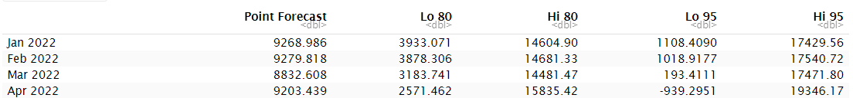

Using time series forecasting techniques, we have projected the profit for the first four months based on data collected from 2018 to 2021.

FORECASTING SALES:

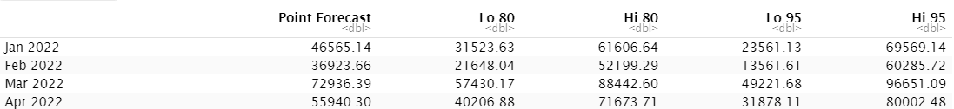

Using time series forecasting techniques, we have projected the sales for the first four months based on data collected from 2018 to 2021.

INSIGHTS FROM THE SALES DATA:

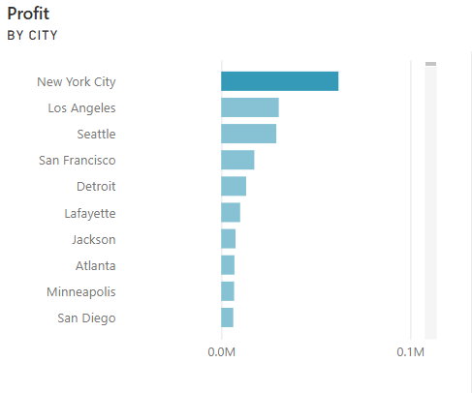

New York City has noticeably more profit.

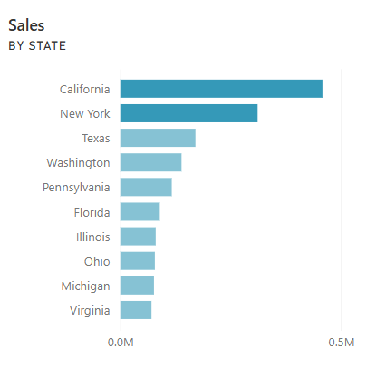

California and New York have noticeably more sales.

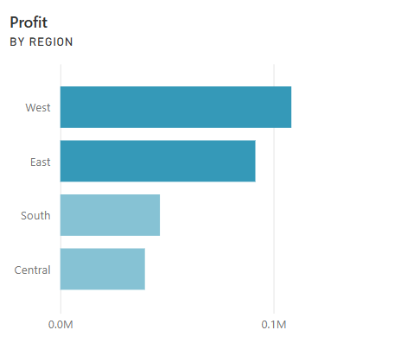

West and East have noticeably more profit.

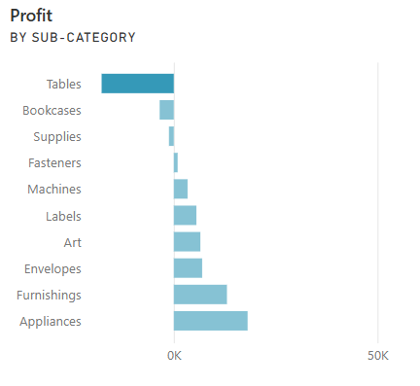

The table has noticeably less profit.

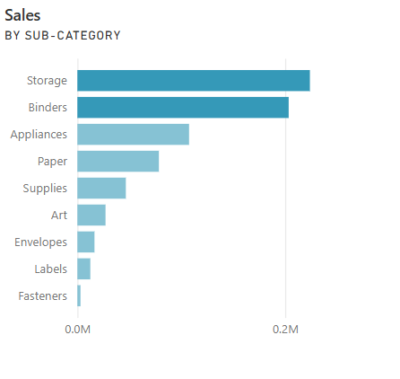

Storage and binders have noticeably more sales for the category of office supplies.